HostAlert

Functional Specification

Version 2.1.8
October 2005

Table of Contents
Introduction 4
Software Overview 4
Product Description 4
Product Functional Capabilities 4
Product Features 4
User Characteristics 5
Assumptions 5
3rd party Software 5
Internal Function Descriptions 5
Management 5
Processing 6
Queuing Middleware 6
Inputs 8
Outputs 8
Metrics 8
Windows Desktop Application 9
Wire Frame 9
Features and Menus 9
Touch Screen Layout - 14
Windows Mobile Handheld Application 14
Pocket PC Layout 15
Advanced Reservations 16
Touch Screen Layout – Reservations 17
Internet Reservations 18
Hardware and Network Configuration 18
Hardware and Network Configuration – Example 20
Hardware Configuration List 20
Hardware Configuration List 21
Certified Hardware 21
Communication Interfaces 22
System Attributes 22
Performance 22
Design Constraints 22
Security 22
Reliability and Availability 22
Installation, Maintenance, and Upgrades 22
Usability 23
Database 23
Administration 23
Backup and Restore 23
Documentation 23
Appendices 25
Appendix A - Relational Data Tables 25
Appendix B - Database Relationships 26
Appendix C – Reports 27
Walk-In Summary 27
Daily Snapshot 27
Cover Count Summary 28
Wait List Detail 28
Reservations Summary 28
Seat Utilization 28
Trend Statistics 29
Server Turn Times 29
Reservations List 30
Special Reservations 30
Staff List 30
Table Setup 31
Reservation Origin 31
Reservation Referrals 32
Customer List 32

Introduction
This specification is organized in sections representing major components of the overall solution. Software, Hardware, and Communications issues are discussed throughout the document.

This document is intended as a living document for the current versions of the HostAlert products. It is intended as a guideline for development rather than a description of how development should operate.

Software Overview

Product Description
HostAlert enables host manager’s access via fixed and mobile terminals for seating management within a restaurant. Guests are also provided with accurately estimated wait time for their table. HostAlert manages pager communication so guests know when their table is available and servers know when a table has been sat. Reservations functionality is also provided. The base HostAlert product has a very limited reservations capability. Optional “advanced” reservations is a licensable option and optional web reservations (monthly fee) are also available.

Product Functional Capabilities
- Seating Management
- Wait Time Estimates
- Guest Communications
- Reservations Management
- Reports

Product Features
- Prompt seaters to choose appropriate tables
- Facilitate station rotation for balanced seating
- Facilitate automating waiting time quotes
- Allow staff to update table availability via mobile device
- Automatically matches, selects and pages the next party
- Reduces verbal communication
- Increases restaurant efficiency with wireless mobile devices
- Increases efficiency with intuitive designs
- Requires minimal training for swift implementation
- Consumer searching and booking of reservation via Internet web browser (optional monthly service directly with Ameranth)

User Characteristics
Users of HostAlert are typically restaurant hosts and managers. They are not typically technically inclined meaning that the application must be simple enough to use in this environment without much technical assistance.

Assumptions
HostAlert operates in a restaurant area. An Ameranth trained administrator administers all application software. HostAlert only works on Microsoft Windows platforms.

3rd party Software
Ameranth HostAlert requires the following 3rd party software to be installed on various system components prior to use.
- Microsoft Active Sync
- Microsoft SQL or MSDE Database Engines
- Microsoft Pocket Access
- Mount Focus Software Keyboard

Internal Function Descriptions

Management

Seating Management
Station Rotation – Manager preferences; party size, table size, equal cover count, time since last seated, order stations opened
Seat Utilization – Party size to table size ratio
Available table matching based on preferences – smoking, non-smoking, and high chair. This feature is completely manager definable.

Wait List Management
View guest seating list
Reservations, Walk Ins
How long a guest has been waiting
Quoted time
Customizable sort
Customizable layout
Custom color code for status

Reservations (Base)
Book reservations for future days

Reservations (Advanced)
Book reservations for future days
Reservation/visit history by guest
Granular inventory of availability
Graphical reservation book
Hotel/Concierge referral tracking
Send reservation confirmation e-mail

Processing
Wait Time Estimates:
- Balanced Seating Properties
- Options are changed
- Party is seated
- Station opened or closed
- Table is cleared or occupied
- Wait list is changed
- Table properties are modified
- Table desirability properties

Queuing Middleware
Wireless Sync is suited for applications running on mobile devices connected via a wireless LAN. These applications need to interact with a server application to access live data. However, because the connection is not guaranteed at all times, they need to be able to recover from a connection loss. The queuing application provides a sophisticated mechanism to allow communication between a mobile device and its server counterpart.

Queuing for both Client and Server Applications: Client and Server applications are able to post messages to their counterpart server or device. The current connection status does not affect this functionality. Messages are continually posted (from either end) and the middleware queues the messages if the device is s not currently connected. Upon connection, the messages are sent.
Message Queuing: Delivers queued messages in the order they were posted using FIFO (First In, First Out).
Compression: Can optionally use compression to improve download speed.
Database Operations: Allows the device application to post SQL queries to a database located on the server.
Database Download: Capability to download an entire database from the server to the device. Capability to download a subset database from select tables, records, and/or fields. Full database downloads to the mobile device. Partial database downloads to the device using filters, subset of fields/tables. Can append data to existing and override existing tables. Provides full progress status during download. Supports SQL Server on the desktop PC. Supports QL server and Microsoft Access on the mobile device
Database Upload: Uploads of new data to the desktop PC. Can optionally reset the device table – i.e. ideal for data collection applications. Provides full progress status during upload. Supports SQL Server on the desktop PC and both SQL server and Microsoft Access on the mobile device.
Database Syncing: Supports synchronization of multiple databases. Can synchronize databases of different types at the same time. Logs changes at field level. Logs all changes into a transaction table (per database). Can synchronize multiple devices to a single desktop PC or mobile PC. Custom selection of tables to be synchronized. Each table can have a filter associated to it so that only a subset of the table is synchronized with the device. Provides full progress status during synchronization. Provides various options to reset the synchronization – date/time, snapshot database, etc… Supports SQL Server and Microsoft Access on both desktop PC and mobile device.
Synchronous Messaging: Device is to be notified of a time out – in the event that device is out of range. Device gets the value back without having to use complicated schemes to wait for a reply.
Asynchronous Messaging: Device can post a message to the server without waiting for a reply. The message is posted to a queue first so that it is later sent to the server – in the event that the device is out of range. Otherwise, it is sent immediately.
On Time Delivery: Ensures that messages are delivered only once – I.e. duplicate messages are not delivered.
Connection Status Feedback: Application running on device is notified within a few seconds if connection is dropped or if can not be established. When connection is dropped, the middleware notifies the device application gracefully without any errors. No message boxes are displayed.
NT Service: Runs as a service, therefore there is no application window. By using a service, HostAlert avoids potential problems in case a user closes the application inadvertently.
Large Data Transfer: HostAlert is capable of handling large transfers of data (> 1MB) without connection failure and in a timely manner from device to server, and from server to device.
Progress Status: HostAlert provides full progress feedback during download and large transactions.
Notification Window: HostAlert provides notification to a registered window, which can be hosted in a different application on the client side.
Wireless Install: HostAlert provides various options to install software remotely. The client or the server can request a new database download or a complete new install in case the devices was cold booted.
Extensibility: HostAlert is available in library form and therefore can be customized to virtually anything. The library can be compiled and linked to an MFC application, which has access to all the base functionality. The library can be extended to modify the default behavior or by adding new functionality to it. Libraries are available for the client side on the device, the server side, and the queuing application on the device.
Source Code Option: HostAlert is also available in source code form for full customization.
Logging: HostAlert supports full logging of all transactions. All messages processed by the server are logged in a specified location.
Device Monitoring and Status: Includes a server application (HTTP Viewer) that displays various information about all the devices, i.e. their connection status, the last time they were connected, messages for all devices, etc. This monitoring feature is available for each registered application.
Multiple Database Support: Can connect to virtually any OLEDB or ODBC database on the server and any OLEDB/ADOCE database on the device.
Wireless and Internet Support: Can be accessed via local wireless network, wired network, and wide area network over the Internet.

Inputs
Touch Screen Interface: Hosts can request table seatings through a user friendly touch screen interface or a traditional mouse and keyboard combination.

Outputs

Host Station Updates: Updates reflecting the current state of every table in the restaurant

Pager Communication: Pages to customer, manager, server, bus boy, anybody with a pager
Receipts: Seating chit, assignment chit, return time chit
Reports: Walk-In Summary, Daily Snapshot, Cover Count Summary, Wait List Detail, Reservations Summary, Seat Utilization, Trend Statistics, Server Turn Times, Reservations List, Special Reservations, Staff List, Table Setup, Reservation Origin, Reservation Referrals, and Customer List

Metrics
- Decrease guest wait times for tables
- Reduce labor required for managing guest seating
- Overall guest throughput
- Improved server response time

Windows Desktop Application

Wire Frame

Labels
Seat
Mult
Assign
Table
New
Page
List
Menu
Flash

Guests
Staff
Resv
Status
Guest Name
Remaining
Quoted
Page/Phone Number
Size
Table Type

Guest waiting list with parameters noted above.

Station
Server
Occupied Tables
Last Seated
Total Covers
Pager
Assigned Tab
Guests
Staff
Resv

View the Staff List in columns noted above.

Guests
Staff
Resv
Station
Server
Occupied Tables
Last Seated
Total Covers
Pager
Assigned Tab

View all reservations for the day in columns noted above.

Features and Menus
Menu

A drop down list to access Manager Functions, Station Templates, Reports, Help Screen and to Exit the application
Manager
Login
Logoff
Customize View
Setup
New Room
Edit Room
Delete Room
New Station
Delete Station
New Employee
Delete Employee
Manage Employee
New Guest
Delete Guest
New Table
Delete Table(s)
Setup Lock
Options
Start Day
Forced DB Download
Create Handheld Bitmaps
Copy Bitmaps to Device
Backup Utility
Refresh
Print
Daily Report
Guest Report
Print Reservations
Waiting List
Wait List Snapshot
Wait Detail
Seated Snapshot
Print Server List
Print Table Details
Turn Times
Station Templates
New Template
Edit Template
Prepare Shift
Create Duplicate Template
Use Template
Save and Close
Delete Template
Display
Toggle Icons
Display Pickups
Toggle Keyboard
Bulletin Board
Help
Exit

Flash

Tap this tap once to display a list of reports that default to relevant real-time reports
Daily Snapshot
Cover Count Summary
Expected Covers
Trend Statistics

Labels

Tap this tab once to display how long each table has been occupied, again to display how long until it should be available and again to show the assigned server names and once more to turn off.
None
Seated Time
Remaining Time
Staff Assignment

Table

Select a table and tap this tab to update the table status. Colors are manager definable.

█ Seated
█ Clean
█ Dirty
█ Reserved
█ Drinks
█ Entrée
█ Dessert
█ Check Down
█ Paid
█ Pre Assigned

Details
Table Info
Table Number
Type
Seating
Min/Max
Shape
Desirability
Group
Station
Server
Table Type
Custom
Custom
Icons
Table Icons
Open / Close Table(s)
Combine Table(s)
Transfer Party
Unassign Party
Unseat Party
Un-Pickup table
Align Horizontally
Align Vertically

Assign

Assign a server to a table or pre-assign a table to a guest on the waiting list.

Seat

Seat a guest at a table.
Multiple

Seat a guest to multiple tables or assign a server to multiple tables.
New

Begin the procedure for seating a new guest or adding a new guest to the wait list.

(Wire Frame)
Table Type
Walk In
Party Size
Seat
Wait
Call Ahead
Reserve
Cancel
Estimated Wait Time:
Page

Send an electronic page to a staff member or to electronically notify a waiting guest that their table is ready (system must be interfaced with a compatible paging system to use this function).
List

List is used to filter the wait list and open/close server stations

Find
Find Next
Find Pager
Reset Sort
Reset Column Sizes
--------Filters --------------
Paged
Pre-Assigned
Reserved
Arrived reservation
Arrived
Call Ahead
Waiting
Seated
On Hold
Finished
Walk Away
No Show
No Show Call Ahead
Self Seating
Deleted
Cancelled
All
All Active
All with Finished
Custom Filter / Sort
Preferences
Walk In
None

Page Group
Open / Close Station
Open All / Close All
Unassign All Servers

Touch Screen Layout -

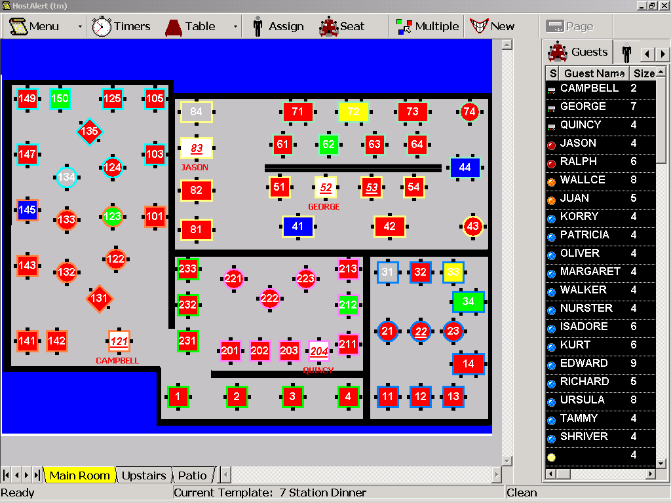

Windows Mobile Handheld Application

The handheld application contains a subset of features to those found in the desktop application. Using the handheld users can:

- Quote wait times to customers
- View current wait list
- Add customers wait list
- Remove customers from wait list
- Seat customers to tables
- Update table status (e.g. dirty to clean)
- Transfer seated parties
- View graphical table/status
- Initiate alphanumeric pager communications
- View bulletin board notes

Pocket PC Layout

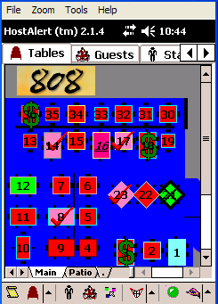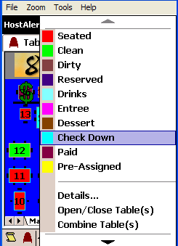

Advanced Reservations
This is an optional licensable module that provides additional features beyond those found in the base version of HostAlert. Advanced Reservations consists of:

- Inventory of availability (slots)
- Reservation book (displays both available and occupied slots)
- Guest list (for tracking repeat customers)
- Select reports
- Optional settings

The Advanced reservations module allows a manager or administrator to control their inventory of availability through a combination of attributes:

- Time
- Party Size
- Type (Block, In-House, Internet, Normal)
- Exception rules (for holidays and special events)

Touch Screen Layout – Reservations

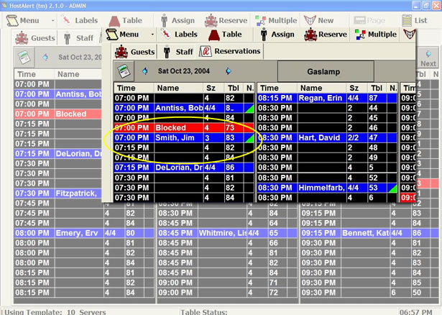

Internet Reservations
This module will be available in addition to the Advanced Reservations module. It is an additional monthly license fee, paid directly to Ameranth.

Restaurateurs want to allow some of their reservations inventory to be available to customer via the World Wide Web. Restaurateurs will place an Ameranth supplied IFRAME on websites of their choosing.

Customers will use a web browser and the IFRAME to search and confirm reservations directly into the HostAlert database in the restaurant.

A windows service application will manage searching and confirming reservations into the HostAlert database on behalf of restaurant patrons in the restaurant. The service will communicate with an intermediary Datacenter computer to ensure security. Restaurant patrons will be able to request availability that match the following user-specified criteria:

- Date
- Time
- Party Size

Upon receiving a request, the service will match available slots from the HostAlert reservations inventory placing them on hold for the Internet patron for a restaurant specified period of time (HoldMinutes). The patron will either confirm a reservation in one of up to three slots or search again. All unconfirmed slots will be automatically released back to available inventory after the value of HoldMinutes.

The windows service must be able to operate behind a firewall. The windows service will establish a connection to the intermediary datacenter. If a restaurant’s windows service does not have a connection to the datacenter the restaurant patron will not be able to search or confirm reservations.

Hardware and Network Configuration

Below is a high level view of the various components of the system. All inter device communication occurs via wireless TCP/IP communications protocols. The Main Computer hosts the core of the service, and does not require any other component to fully function.

Pagers
Handheld Wireless PCs
Main Computer
Hub / Switch
Pager Transmitter
Client Computer
UHF
TCP/IP
Serial
TCP/IP
TCP/IP
Serial
Printer

Hardware and Network Configuration – Example
Pagers
Handheld Wireless PCs
Main Computer
Hub / Switch
Pager Transmitter
Client Computer
UHF
TCP/IP
Serial
TCP/IP
TCP/IP
Serial
Printer
SmartAlert UHF Transmitter
2.4 GHz 802.11b/g
Jtech Glowsters
Guest Pagers
Alphanumeric Pagers for Managers & Staff
Microsoft Windows Mobile

Hardware Configuration List
HostAlert must operate on the following minimum configuration. This configuration was established to balance cost and performance for final deployment into customer sites.

Workstation
OS - Windows 2000, XP
CPU – Pentium III 700Mhz
RAM - 256MB minimum (512 Recommended)
HDD - 20GB or larger
DISPLAY - SVGA 1024x768
TOUCHSCREEN

Handheld Devices
OS - Microsoft Windows Mobile 2003 or Pocket PC 2002
DISPLAY - Color, touch-panel 240x320
Wireless NIC 2.4GHz IEEE 802.11b/g

Wireless Access Point
2.4GHz IEEE 802.11b/g
Network
100-base Ethernet

Certified Hardware

The following hardware is supported. Additional hardware can be certified at our customer’s request and expense.

Workstation / Server
Dell Optiplex

Handheld
Symbol PPT 8846 with Windows Mobile 2003
Symbol MC50 with Windows Mobile 2003

UHF Transmitter
Smart Alert 450-471Mhz

Pagers
Jtech Glowsters
Sytech Alphanumeric pagers
Guest Pagers
Printers
Epson TM88II or III – Receipt Printer

Communication Interfaces
HostAlert supports a combination of TCP/IP over Ethernet and 802.11b/g wireless communications between Main Station, Client, and handheld device(s). Serial interfaces to the UHF Transmitter and POS printer.

System Attributes

Performance
HostAlert is a real time application requiring immediate user feedback and continuous data updates.

Design Constraints
HostAlert must run on a handheld device running Windows Mobile 2003. This implies memory constraints of 16MB for the application and 32 to 64 MB of flash memory for the database and any other associated files.

The entire application must operate on the system hardware noted above.

Security
Application: HostAlert is password secured to separate Administrators (Managers) from Users (Hosts, Wait Staff, and Support Staff). Access to reports and any other administrative function are controlled via password protection. Users do not have access to the password file as it is stored in the SQL database leveraging the Microsoft secure database access.

Network: The wireless hub supports a 128 bit key that will be required to connect to the server. This, in conjunction with the security rules for Microsoft networking provides a customizable security package.

Database: SQL requires a password to access the database. This service has many rules to set up user roles in general.

System: System access protection is provided via standard Microsoft user accounts.

Reliability and Availability
HostAlert must be both reliable highly available. Handhelds must operate independent of the base computer in case of main server failure.

Installation, Maintenance, and Upgrades
Installation: Installation must remain flexible to support customer requirements. All installations can be centrally managed, as well as individually installed.

Either an Ameranth employee will perform installations, an Ameranth certified reseller/partner such as Jtech, or an IT manager of the customer.

Software Distribution: Software updates and installations are delivered via HTTP, CD-ROM.

Scheduled Maintenance: Scheduled maintenance includes updates

Unscheduled Maintenance: Periodically as issues arise, Ameranth will need to make an unscheduled update to the application. This update requires communication with the customer so they understand what issues are being addressed by the update, and so they know how to install the update.

Upgrades process: Ameranth announces upgrades, with the update going either to the partner/administrator or directly to the customer from Ameranth.

Usability
HostAlert is intuitive for the common User (Manager, Host, Wait Staff, and Support Staff). Usability tests are run after initial installations are up and running. Feedback from these usability tests will assist in future releases of the service but are not relevant to this functional specification.

Database
HostAlert requires Microsoft SQL or MSDE server, and Pocket Access on the wireless handheld devices. For Database Architecture, see Appendix B.

Administration
An Ameranth certified administrator manages HostAlert application software. Ameranth partners will be the primary customer interface for installations, updates, and maintenance.

Backup and Restore
Ameranth: Ameranth does not provide either backup or restore functionality for the application. There is a utility called HostAlert Backup on the Main Menu for backing up and restoring the database on the local hardware. This utility can be scheduled to run at various intervals.

Microsoft Standard: MS-SQL server has full backup and restore capabilities built into the database manager. These can be used for non-supported backup and restore functionality as required by the customer.

Handheld: HostAlert supports a recovery mechanism that restores the application and all existing settings in case of power loss.

Documentation
Documentation is available in printed, web, and PDF format to support the various ways Users will learn about the product.

User Documentation: This is a quick guide to learning the service covering only the basics of how to seat a customer. It should fit on an 8 ½” x 11” two sided plastic covered piece of paper.
Restaurant Management: Cover the entire application so they could themselves train individuals on the service and be an expert in the use of the service. It will have to cover parts of the application that are not accessible to Users (Staff) such as reports and section management.
Administrator/ Partner: Enables partners such as Jtech to install and administer HostAlert sites around the world. It will include everything from how to install the core products, to how to trouble shoot known issues with the SQL database and operating system.

Appendices

Appendix A - Relational Data Tables

Reservations
UID
Name
Phone
Party Size
Reserved Date
Date Reservation Made
Notes
Preference1
Preference2
Preference3
Standard Notes
First Name
Last Name
Address
City
State
Zip
Email
Attributes
On Wait List
Cancelled
External Res ID
External Cancel Code
Customers
UID
Name
Size
Arrival Time
Quoted Time
Time
Tables
Pager
Notes
Status
Reserved Time
Table UID
Preference 1
Preference 2
Preference 3
Time Seated
Standard Notes
Time Departed
Guest ID
Meal Period
Time Created
Time Paged
Priority
Return Time
DOW
Wait Alert
Attributes
Reservation UID
Est Wait Time
Tables
UID
Name
Seating
Type
Shape
Back Color
Text Color
Status
Custom 1
Custom 2
Custom 3
Min
Max
Group
Group UID
Time Seated
Customer UID
Customer Name
Assigned UID
Pre Assigned
Party Size
Room UID
Closed
Slow Alert
Turn Time
Attributes
Cust Attributes
Employee UID
Old Station UID
Desirability
Time Available
Override Close
Employees
UID
First Name
Last Name
Server
Current Covers
Occupied Tables
Time Last Seated
Assigned Pager
Alpha Pager
Comments
Closed
Party Count

Users
UID
User ID
Password
Type
Timeout
Is Minutes

TemplateTables
UID
Template UID
Station UID
Table UID

Station Employee
UID
Template UID
Station UID
Assigned Tables
Employee UID
Closed
Time Opened
Templates
UID
Name

Stations
UID
Name
Color
Notes
Rooms
UID
Name
Page
Bitmap
Notes

Appendix B - Database Relationships

Reservations
Employees
Customers
Template Tables
Tables
Rooms
Stations
Templates
Station Employee

Appendix C – Reports

Walk-In Summary
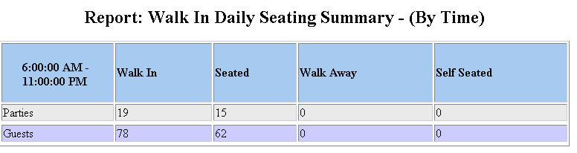

Daily Snapshot
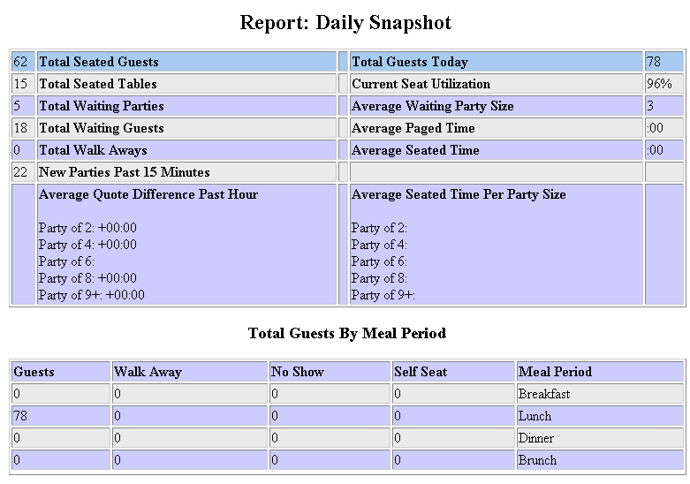

Cover Count Summary
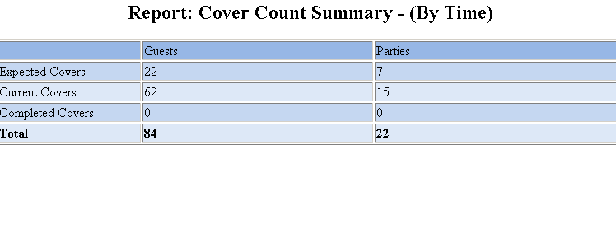

Wait List Detail
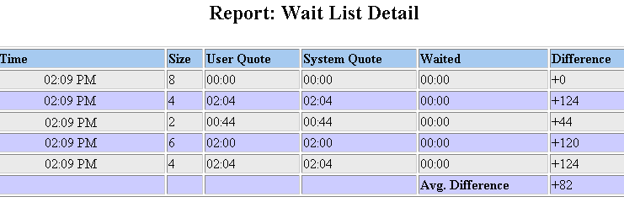

Reservations Summary

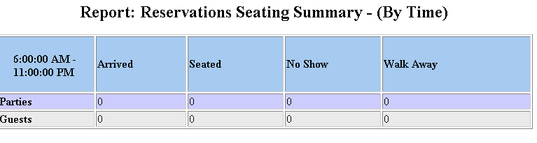

Seat Utilization
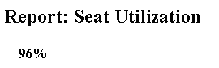

Trend Statistics
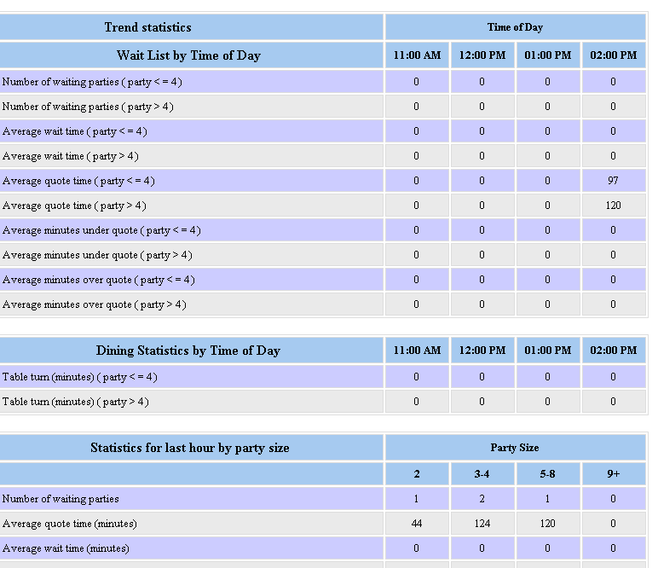

Server Turn Times
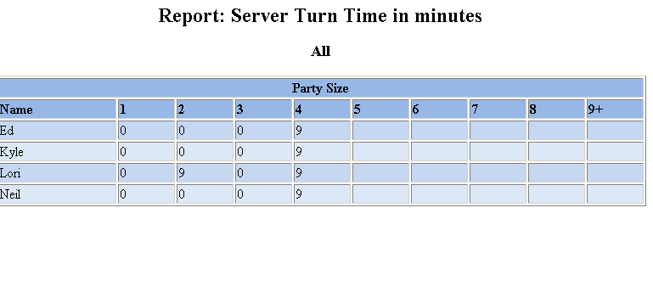

Reservations List
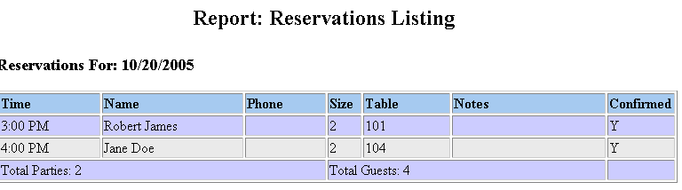

Special Reservations
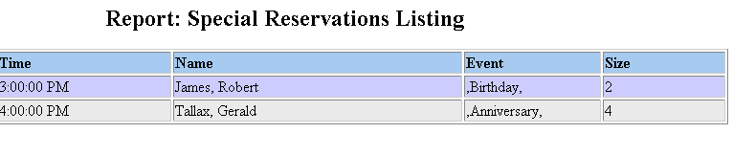

Staff List
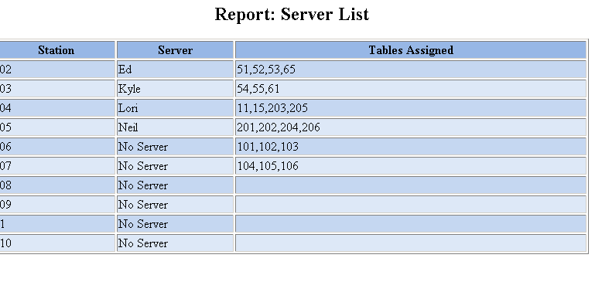

Table Setup
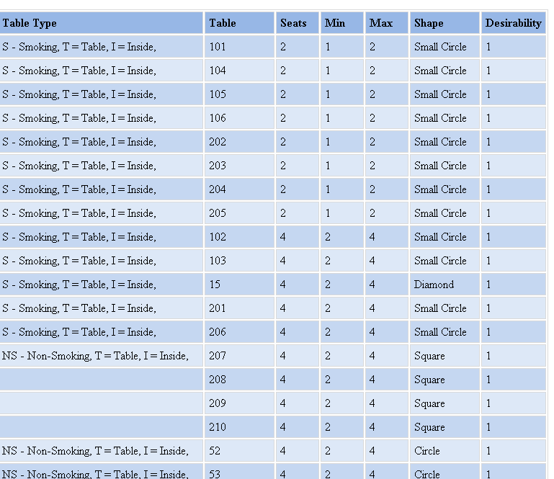

Reservation Origin
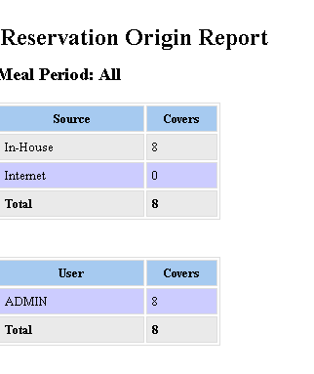

Reservation Referrals

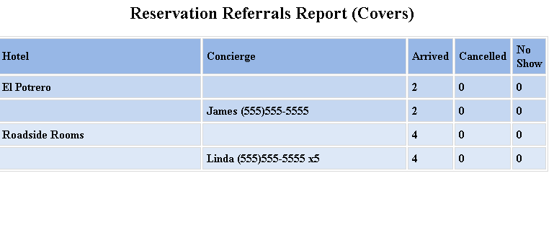

Customer List
