OpenCryptoTrust

Blockchain for Modern Telecommunications

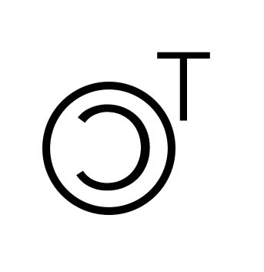

Business Plan

Table of Contents
I. Executive Summary 3
II. Company Description 6
III. Products & Services 9
IV. Marketing Plan 14
V. Operational Plan 18
VI. Management & Organization 20
VII. Financial Plan 21
VIII. Appendices 23

Executive Summary
OpenCryptoTrust (OpenCT) is a robust, high performance, hybrid blockchain platform that enables innovative solutions across multiple industry verticals.

The OpenCryptoTrust platform is flexible enough to support any industry and rigid enough to create the attributes and rule set needed for industry specific transactions. This includes programing to trigger transactions - such as self-executing smart contracts - all tailored to the security, regulatory, legal, and executable standards of an industry.

The industry we are focusing on is the Telecommunications (Telco) Industry. OpenCryptoTrust has spent years developing two applications – Blockchain as a Transport (BaaT) and Blockchain-Defined Wide Area Networks (BD-WAN) that each address significant Telco service problems. BaaT is more cost effective, more secure, and easier to deploy than traditional MPLS solutions.

OpenCryptoTrust will challenge the characterization and standardization of the communication functions within telecommunications and will remove significant cost impacting inefficiencies in the traditional telco model that exist today.

The OpenCryptoTrust (OpenCT) platform is based on a hybrid blockchain. That is, it is both global and public, allowing a diverse range of adoption, users, and clients.

Background

The History of OpenCryptoTrust Blockchain “Killer Apps”

noun: killer application
a feature, function, or application of a new technology or product which is presented as virtually indispensable or much superior to rival products.

Through a New York based consultancy (Seshaat, Inc.) our business and engineering team drives the practical adoption of cutting-edge IT for our clients and partners which include global investment firms, healthcare, international airlines, and multinational manufacturing firms.

The origins of the OpenCryptoTrust platform "Killer Apps"; BaaT – Blockchain as a Transport, and Blockchain Defined Wide Area Network BD-WAN, began in 2013 as a POC (Proof of Concept) developed for one of the largest global investment firms on Wall Street. At the time the goal was to create an optical SDN (Software Defined Network) solution that would support the ability to build up and tear down circuits with provisioning times that were minutes instead of months. Our Optical Architects and Software Development team built this complex, multi-vendor, private solution.

Two years later our consulting team was engaged in another POC for a financial firm and for the first time the concept of leveraging Blockchain technology as a management overlay for VXLAN was successfully implemented.

In late 2016 the "Blockchain Initiative" project was born with the belief that by understanding the specific needs of an industry we could pre-build the necessary framework to ensure the greatest efficiencies and thus ease the barrier to adoption. Our deep understanding of the technical and financial challenges within the telecommunications (telco) industry made this the logical vertical to develop the first of many disruptive "killer apps" that drive adoption to a trusted framework - The OpenCryptoTrust blockchain.

Our OpenCryptoTrust platform has been highly inspired by Graphene – a blockchain network created by the same development team that created the Bitshares and Steemit platforms. It combines many of the features that were critical for us. OpenCryptoTrust platform supports:

Proof of Duration (PoD) - OpenCryptoTrust created it’s own proof algorithm which when used in combination with PoS (Proof of Stake) or DPOS (Delegated Proof of Stake) provides for a more democratic approach to mining and consensus.

A block production rate that is exceptionally fast – 100,000 TPS (Transactions Per Second).

For comparison:

Bitcoin - 3-7 Transactions per second (TPS)
Ethereum - 15 TPS
Visa Credit Card Network - 60,000 TPS

Problem Statement

WAN CAPEX is expensive
  - MPLS circuits are expensive
  - Complex calculation of multi-tier pricing: Local MPLS, Regional MPLS, Inter-regional MPLS – then IP VPN pricing on top of that.
  - Routers are expensive
  - End user pricing is expensive

WAN technologies are not secure, malleable, or scalable. They are cumbersome
- Build up and tear down circuits with provisioning times that take months.
- Customers pay for physical circuits whether in use or not
- Inter-Domain MPLS is rife with security and routing vulnerabilities.
- Low visibility and control over transport facilities either via FTTP or partnership with telco operators and metro ethernet providers worldwide
- Tunneling has scalability issues
- Long term network contracts prevent build out, and cost when over provisioned

Unused Fiber is a wasted commodity

Non scalable VPN solutions

Solution statement
BaaT Solution is superior to MPLS or IP VPN circuits because it provides:
- Cost Efficiency – 30% Total Cost Savings against MPLS
- Performance – 30% faster than MPLS
- Unparalleled Security – End to end encryption, hidden interfaces, invisible routing tables (network)
- Price Simplicity – Pay one price for Point to Point
- Fast (zero-touch) provisioning
- Scalability – Scales infinitely globally

Company Description

Purpose, Mission, Vision, Future

Purpose - To Revolutionize the Telco Industry

Thru the BD-WAN product, Open CryptoTrust has achieved a solution which Telco industry analysts have described as "the Holy Grail application/service for carrier services" - Real Time Bandwidth Usage Billing – against TransAtlantic/TransPacific circuits that leverage SDN (Software Defined Networking) in order to establish and tear down logical as well as physical channels. This will allow the customers to pay only for what they consume as well as reducing their international connectivity costs to the minimum especially the high costs incurred due to the very expensive 'trans-oceanic' links, while allowing customers to scale up or “burst” connectivity during times of peak demand.

Mission - Be the Primary Telecommunications Provider in the Blockchain Ecosystem

Cheaper, faster, better, with less equipment or in some cases no equipment! Open CryptoTrust provides an effective solution to those who have challenges with costly connectivity and gives an option to secure peer-to-peer transactions without the use of any 3rd party or financial institutions.

Execute Our Vision
To build an industry agnostic, scalable, high performance platform that provides the stability and trust from which transformative blockchain based applications can be built that disruptively solve industry specific problems and thus accelerate Business to Business (B2B) adoption of Blockchain.

Future

Killer Apps Will Drive Blockchain Adoption

Blockchain technology is a foundational technology - it has the potential to create new foundations for our economic and social systems. This will take time to evolve. OpenCryptoTrust Killer Apps are disruptive - leveraging technology to attack traditional business models with a lower-cost solution and ability to overtake incumbent firms quickly. The fact that the applications are in themselves "blockchain based" is incidental to the competitive drive towards adoption. The problems that they solve ultimately play an integral part in how Blockchain's broad acceptance will come about.

Proof of Stake Alone - Is Undemocratic

Proof of Work (PoW) - as implemented in Bitcoin for example - requires great energy and power consumption. It simply is not scalable. OpenCryptoTrust has chosen to adopt Proof of Stake (PoS). Using native Proof of Stake (PoS), however, can create an unfair aspect to mining. To overcome this OpenCryptoTrust has invented the Proof of Duration (PoD) algorithm which when used in conjunction with PoS provides a more balanced and democratic approach to mining. With this algorithm, the user is offered a mining opportunity proportional to the duration the token share has been held.

Company formation

Seshaat, Inc.

Open Crypto Trust (OpenCT) and the initial Telco products – Blockchain as a Transport (BaaT) & Blockchain Defined-Wide Area Networking
(BD-WAN) has been developed by Seshaat, Inc. – a New York based ETO (Emerging Technology Organization), that offers deep technology knowledge, relationships, and expertise - across a wide array of industry verticals - Financial, Telco, Real Estate, Healthcare, Energy, and Legal.

OpenCryptoTrust

- OpenCryptoTrust: is the parent company registered in Khazakstan under AIFC English Common Law. This allows Open CryptoTrust to exist tax free.
- OpenCTNet: is a registered Joint Venture business development and sales corporation doing business in Kazakhstan in the Astana Hub.

Founders

CEO - Mayande Walker

COO – Moustafa Amin

Geographical Markets Served

Global

OpenCTNet Location and geographical markets served

Central Asia (Kazakhstan, Kirgizstan, Azerbaijan, Uzbekistan)

Asia (China, India, Thailand)

Europe (Germany, Luxemburg)

Others as demand generates (not bound by geographical markets)

Current status and stage of business

All OpenCryptoTrust current costs and expenses are bootstrapped via Seshaat, Inc. with an annual run rate of approximately $1.7M. A client base for the telco blockchain solutions (BaaT & BD-WAN) has been established from within the Financial and Telecommunication industries (Proof of Concept and Signed Letters of Intent are in place). Demo Equipment has been developed for demonstration and proof-of-concept scenarios which are currently being tested by a major Telco.

Notable achievements

Initial Proof of Concept rolled out in 2013 (one of the largest global investment firms on Wall Street)

Nitec 4 circuit trial in Kazakhstan has been in service since September 2019

Kazakhstan rollout of 28 circuits expected to begin January 2020

Products & Services

Core services

BD-WAN
- Blockchain-Defined Wide Area Networks (BD-WAN): BD-WAN integrates blockchain with Software-Defined WAN (SD-WAN) for a secure, scalable virtualization of WAN transport technologies. Among the unique features (not available with most SD-WAN architectures):
- The ability to dynamically establish and tear down logical and physical circuits so customers pay only for what they consume.
- Inter-Domain MPLS Traffic Engineering via blockchain (near zero time delay).
- Trusted per-usage billings that are verified and hard-coded over the blockchain.
- Full visibility and control over all transport facilities either via Fiber to the Premises (FTTP) or via partnership with key telco operators and metro Ethernet providers worldwide.
- Bringing public cloud and content services seamlessly to the customers' doorstep as part of the standard offering.

BaaT
Blockchain as a Transport (BaaT): BaaT leverages blockchain to create an architecture that can connect geographically dispersed Layer 2 islands over any available infrastructure, including the public Internet. As the resulting solution securely supports all kinds of traffic: Unicast, Multicast and Broadcast - BaaT will become the transport service of choice for all businesses.

Value Proposition of BaaT:

- Because of seamless operation across the public Internet, BaaT is an appealing WAN transport option compared to traditional WAN technologies like VPN, MPLS, or expensive dedicated links.

- BaaT is an advanced L2VPN solution for both enterprises and telco/service providers, with which the organization can leverage the public Internet for their WAN traffic so that they don’t need to share traffic with their upstream providers as in the case of MPLS VPN service or even modern SD-WAN.

- Unlike other tunneling techniques, BaaT is built to operate in a multipoint fashion. Signaling is done separately via the blockchain and it has no scalability issues.

- BaaT can operate over any IP transport network including the global public Internet because no multicast underlay network is required.

- No unknown unicast entry is to be found on any VTEPs; it’s either a unicast MAC address match, advertised over the blockchain, or a default entry toward the VXLAN gateway.

- Multicast and broadcast traffic are handled via the head-end replication on the source VTEP to all other known VTEPs in the same VXLAN. The list of VTEPs is known - and always updated - over the blockchain.

Development stage
OpenCryptoTrust has been deployed as a Trial for Nitec in Kazakhstan. This trial has allowed OpenCryptoTrust to be chosen as a technology currently under contract to rollout OpenCryptoTrust BaaT technologies into all of Kazakhstan.

OpenCryptoTrust is production ready and has plenty of future development available to improve on the vision of the technology.

Screenshots / diagrams

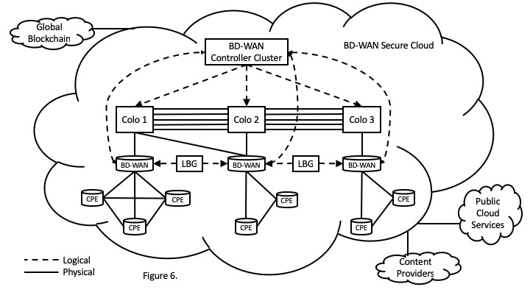

Current pricing summary with Pricelist

A PVC circuit includes network switch devices with BaaT software, Network Operating System (NOS), Encryption (security), and network connectivity for each circuit. It is estimated that Network Switch devices will be replaced every 5 years with updated hardware/software configurations. An SVC Circuit is a software licensing element that connects existing PVC Point to Point connections to each other without additional network drops or hardware.

OpenCryptoTrust charges based on the number of circuits ordered. There are 2 options for OpenCryptoTrust to provide a price list provided to a customer; burdened and unburdened. Burdened includes the cost of doing business for this particular customer in this particular region with these particular business practices. Costs include factoring, duration of a sales quote, volatility of the currency in the region, and on-time payments. Unburdened price list has these factors removed and represent risk taken by the customer rather than by OpenCryptoTrust.

Burdened

One example of a burdened price list has the lowest volume, a single PVC circuit cost $15,723/mo including 1Gb bandwidth per circuit per month, and at the high end, 1000 circuits cost $12,926 including 1Gb bandwidth per circuit per month. SVCs cost $1,683/mo for low volume, and $647/mo for high volume. Each burdened price list will be different depending on the circumstances of the customer.

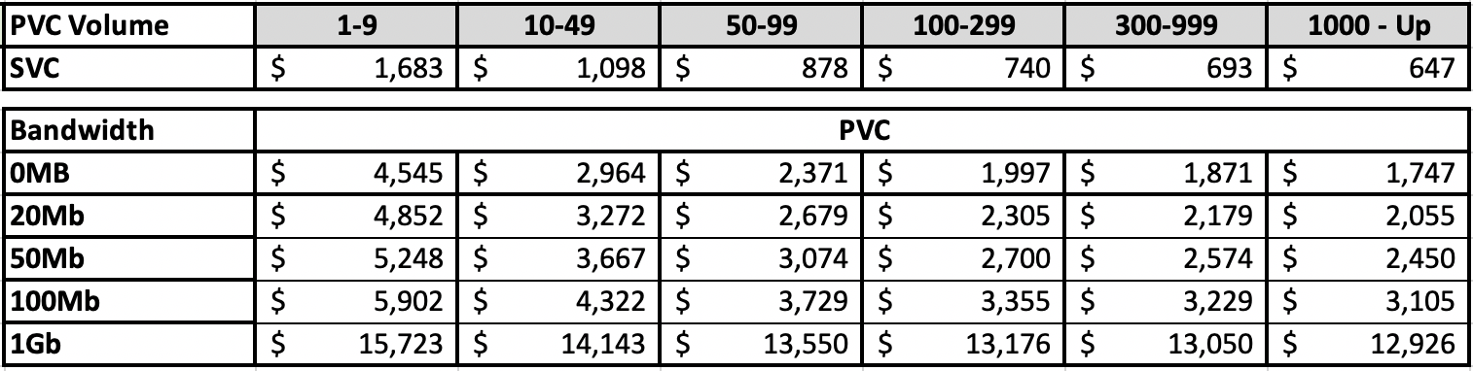

Unburdened

When the customer takes on all financial risk, the unburdened lowest volume single PVC circuit costs $10,502/mo including 1Gb bandwidth per circuit per month, and at the high end, 1000 or more circuits cost $8,834 including 1Gb bandwidth per circuit per month. SVCs cost $1,518/mo for low volume, and $584/mo for high volume.

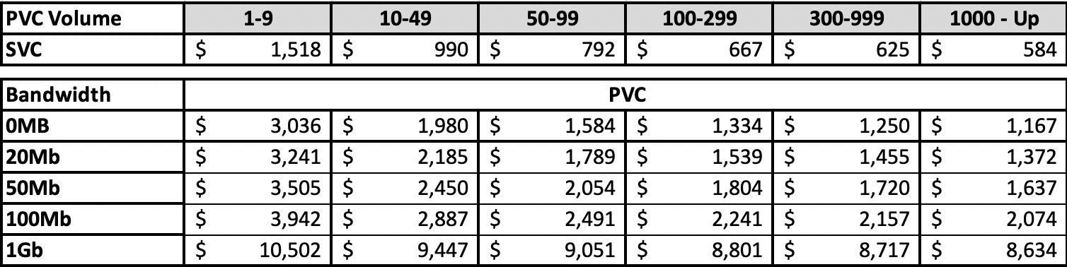

Test results of both Security and Performance

In September of 2019, a Proof-of-Concept (POC) for Blockchain-as-a-Transport (BaaT) was implemented for a NITEC Data Center Interconnect (DCI) at two (2) Data Centers (A. Nur-Sultan; Z. Almaty) within Kazakhstan. It leveraged a public Internet (1 Gigabit) ethernet handoff and a private OpenCryptoTrust blockchain (for securitized performance testing).

BaaT was compared and contrasted (from a performance, security, and cost perspective) against the existing MPLS/IP VPN circuit. Our team performed over 84 file transfer tests with a total of over 200 Gig of data between the data centers.

As indicated in the graph the BaaT Circuit had 18% better bandwidth efficiency than existing IP VPN – with a bandwidth tax of 2% instead of 20%.

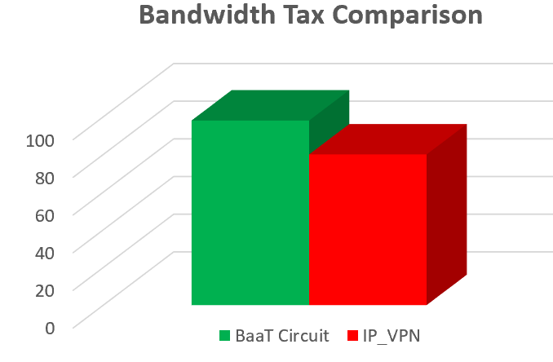

The performance of these data transfers was consistent – showing excellent performance of bandwidth across highly encrypted, “invisible” circuits leveraging the Internet.

Future products and services

White Label Managed Services

OpenCryptoTrust Marketplace

Consulting

Industry Specific Disruptive Applications

Acquisition

Marketing Plan

Competition and market research

Multi-Protocol Labelled Switching (MPLS) is the entrenched provider of point to point networking for Telcos, companies and organizations.

Internet Protocol (IP) Virtual private network (VPN) IP-VPN is provided by hundreds of vendors using varied technologies. The top 3 VPN vendors are ExpressVPN, NordVPN and Hotspot Shield. These vendors typically have both a free and paid version of their VPN software. The top vendor, Express VPN, has over 1.7 million unpaid users of their application.

SWOT analysis

Strengths
BaaT Solution is superior to MPLS or IP VPN circuits because it provides:

Unparalleled Security

Stealthy

Performance

Cost Efficiency

Price Simplicity

Fast (zero-touch) provisioning

Scalability

Point to point

Rapidly scalable

Weaknesses

OpenCryptoTrust is the new technology on the block. No large telecommunications provider is using the technology.

OpenCryptoTrust is small, attempting to compete against network giants such as Cisco.

Opportunities

MPLS and IP-VPN are expensive and not as secure

Threats

Time – Once out of the bag, this type of technology will quickly become a standard. First mover advantage can only last so long

Blockchain for Telco’s is one of the hottest IP filing technology areas

Unknown other disruptive networking technologies

Market research

Total Market Size

SD-WAN
  - The global SD-WAN market size is expected to grow from USD 1.0 billion in 2018 to USD 4.1 billion by 2023, at a Compound Annual Growth Rate (CAGR) of 32.7%

MPLS
  - The managed MPLS market was valued at USD 45.61 billion in 2018 and is estimated to register a CAGR of 6.5% during the forecast period (2019-2024). With businesses expanding rapidly, MPLS is becoming the preferred choice of enterprises, as it offers excellent quality of service when it comes to avoiding packet loss and keeping a business’s most important traffic flowing.

VPN
  - The global virtual private network market is slated to grow from its current value of USD 17 billion to over USD 54 billion by 2024; according to a new research report by Global Market Insights, Inc. The VPN market is propelled by the rising number of advanced and complex cybersecurity threats.

Fiber Optics Market
  - The Global Fiber Optics Market is estimated to be valued at USD 2.85 billion in 2015 and is projected to reach USD 5.00 billion by 2021, at a CAGR of 9.8% from 2016 to 2021.

Total Addressable Market (TAM)

OpenCryptoTrust’s TAM includes the SD-WAN, MPLS, and VPN markets making the entire technology replacement market over $66 Billion in total value.

Product positioning

SD-WAN / MPLS / IP-VPN Replacement

Secure Network

Dark Fiber Utilization

Elevator pitches and taglines

The future of Telecommunications

Securely connect anywhere at will

Real time provisioning

Have all cloud and content delivered to your doorstep

Eliminate circuit charges based on fixed fees

Never be locked in long term contracts

Only pay for the bandwidth you actually use

Target customer personas and profiles

Telecommunications provider interested in reducing costs while improving performance and security of data transmitted.

Smaller telecommunications provider interested in providing unique, cost effective inter-continental data transmission.

Countries interested in secure network data transmission and saving money over traditional SD-WAN / MPLS / IP-VPN solutions.
4. Direct sales to global enterprise customers who want cost effective data transport along with superior data encryption.

Results of Market Testing

Initial marketing tests for OpenCryptoTrust have shown that Business Development will be driving most of the sales. In Kazakhstan the Nitec project came from Business Development activities. In each of the regions where OpenCryptoTrust has a foot hold, all deals have come through Business Development activities with limited support from Marketing.

It is expected that Marketing will evolve with investment and market growth based on visibility and revenues. The Marketing Budget is based on industry norms with an eye to effective ROI based marketing. Marketing will take on building the sales pipeline and demand once it is staffed and has an active budget.

Marketing channels
Marketing channels for OpenCryptoTrust will be the same as for MPLS and IP-VPN. Initially including Tradeshows and online presence, OpenCryptoTrust will expand the breadth and scope of its marketing channels with either investment or revenue.

Tradeshows

Mobile World Conference 2020 Barcelona, Spain

OFC The Optical Networking and Communication Conference 2020 San Diego, CA, USA

MPLS + SDN + NFV World Congress 2020, Paris France

Others as discovered

Marketing

Online Presence (Website, Social Profiles, SEO, Wikipedia, etc.)

Videos (Training, Marketing, Promotional, etc.)

Collateral (Whitepapers, Brochures, etc.)

Advertising (PPC, Video, Social, etc.)

Social Outreach (LinkedIn, Facebook, etc.)

Research (MPLS Market, IP-VPN Market, etc.)

Marketing budget
The marketing budget is set to industry standard of 7% of Net Revenues of $22M for a B2B Service company. Investment will increase the Marketing Budget based on new projections of sales.

Item | Amount
Tradeshows (8 at $100,000 each) | $800,000
Online Marketing | $200,000
Personnel | $150,000
TOTAL | 1,150,000

Operational Plan

Facilities and space

Headquarters: Astana Hub, Nur-sultan, Khazakstan

Distributed Team in; Egypt, Spain, Germany, Saudi Arabia, Pakistan, USA, and India

Technology

BaaT – Technology already in production. Requires product management best practices and Product Roadmap.

BD-WAN – Technology already in production. Requires product management best practices and Product Roadmap.

NOS – Technology currently licensed for ease of deployment. Requires Product Roadmap and Product Requirements Document.

Security – Technology currently licensed for ease of deployment. Requires Product Roadmap and Product Requirements Document.

Integrated Technology – Each Technology is currently stand alone and not tightly coupled. Requires Product Roadmap and Product Requirements Document / Product Strategy Document.

Equipment

Whitebox Switch – Larger rack mountable switch that contains up to 45 circuits. These are typically used in datacenters.

Blackbox Switch – Smaller, more cost-effective end switch with up to 3 circuits. These are typically used in offices.

Supply chain

Hardware Vendors: Edgecore, Protectli

ISPs: Kazakhtelecom, Beeline

Order and fulfillment processes
Customers cannot currently just order the software. They purchase a service that includes both the hardware and the software. In some cases it will include Internet as well. Due to this fulfillment process, and the ongoing service required to keep the devices and the applications running, orders are long term contracts.
Orders are fulfilled by OpenCryptoTrust installation teams who install and test the equipment on premise.

Quality control checks

Connectivity

Blockchain Check

Configuration review

Node check

Performance Check

iPerf Internet Bandwidth Check

Speedtest CLI (Upload / Download / Latency)

Expected ISP Bandwidth (Above MAB of 930Mb/s?)

BaaT Bandwidth (BaaT Overhead measured)

Data Transfer Test

Small, Med, Large files

Data Transfer over time

Security Test

Device Hardening Verification

Encryption check

Legal and accounting

Legal

White & Case - HQ in NYC and a strong presence in Kazakhstan and London within Cryptocurrency/blockchain space.

John Osborne – Intellectual Property

Accounting

Ernst & Young or PWC

Management & Organization

Founders and team

CEO - Mayande Walker

COO – Moustafa Amin

CTO – Jeff Doyle

CMO – Stuart Hall

CSO – Paul Valenzuela

Managing Director of International Business Development – Arnur Amirgaliyev

Director Product Development – Rob Lewis

Director DevOps - John Martinez

Director of International Business Development - Eric Cavalier

Director Business Development - Carolyn Biryla

Owners and shareholders

55% Mayande Walker

10% Paul Valenzuela

25% Investor Set Aside

10% Employee Set Aside

Board of Directors

Currently Searching For Industry Luminaries

Consultants and special advisors

Jeffry Sesol - Co-Founder and CTO Freedrive

Keith McNally – Founder and CEO Ameranth

John Osborne – IP Lawyer

Financial Plan

Financial projections (000’s)

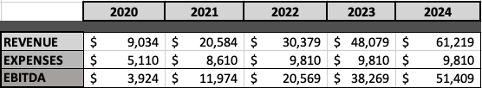

Break even analysis

It is estimated that break even can be attained in 2021 using 2020 projected sales.

Investor Capitalization

Equity Investment Model

$10M – 1.5% Equity

Note: OpenCryptoTrust has right to purchase back 50% within 36 months at strike price of $1.5M per equity share.

$20M- 3.0% Equity

Note: OpenCryptoTrust has right to purchase back 20% within 36 months at strike price of $2M per equity share.

Use of funds

Low - Current funding are to be used for deployment of the OpenCryptoTrust system in Kazakhstan for Nitec. Funds will be used to manage capital requirements of OpenCTNet including software license payments to OpenCryptoTrust.

Med – Use of funds to grow and develop the Asian and European markets, following up on the current business development pipeline with Deutsch Telecom, Communication Authority of Thailand (CAT), SES Networks, and Agorai.

High – Funds to be used to open 3 regions simultaneously and accelerate software development efforts to have a fully integrated solution.

Milestones

Wall Street Firm – Prototype

Nitec – Trial – 4 circuits – September 2019

Nitec – Phase 1 – 28 circuits – May 2020

Nitec – Phase 2 – 1000 circuits - 2020

Nitec – Phase 3 – 5,000 circuits – 2021 to 2024

Completing projects and years

BD-WAN 2020

BaaT 2020

NOS 2021

Encryption 2021

Appendices

Articles of incorporation and status
OpenCryptoTrust is a Kazakhstan registered corporation and has a certificate
of registration as a participant of the International Technology Park of IT-startups "Astana Hub". Benefits of being an Astana Hub member:
- Application of common law
  - Own Independent Dispute Resolution System. The legal system in the AIFC is based on the principles and jurisprudence of England and Wales.
- Special tax regime
  - Exemption from payment of corporate, individual income, land tax and property tax for a period of 50 years (until the end of 2065).
  - Opportunity to receive tax benefits: CIT - 0%, VAT - 0%, social tax on non-residents - 0%.
- Simplified VISA regime
  - A visa-free regime will be provided for up to 30 days for OECD, UAE, Malaysian, Singaporean and Monaco citizens. Participants of the AIFC and their family members will enjoy a special visa regime with the possibility of extending to 5 years.
  - The opportunity to get a simplified visa and labor regime for foreign participants of the Astana Hub technology park for companies where non-residents work.
- Regulatory "Sandbox"
  - “Sandbox” is one of the most common words in the fintech universe. In the financial industry, the term refers to a mechanism for developing regulation that keeps up with the fast pace of innovation.
- Knowledge and useful contacts for attracting investment on favorable terms.

OpenCryptoTrust is taking advantage of a tax-free zone for incorporating and domiciling in Kazakhstan. OpenCryptoTrust is one of the premier lighthouse corporations for this tax-free zone.

Kazakhstan – OpenCryptoTrust

Kazakhstan – Joint Venture - OpenCTNet LLP (OpenCTNet)

Resumes of founders and key team members

OpenCryptoTrust_Team Bio (DOC)

Mayande Walker

Moustafa Amin

Rob Lewis

Arnur Amirgaliyev

Jeff Doyle

Whitepaper

OpenCryptoTrust Platform Whitepaper V2.11 (DOC)

Trademarks and patent registrations

Provisional patent filing - February 2019 – Open CT Diagrams for IP Filing (PDF)1

Utility Patent - February 2020

Current Pricelist

Contracts

Nitec

Andrey’s Letter of Agreement

